

​​
Computer Organization and Design
40201200
Section (1)

Computer Organization and Design take home

Submitted to
Huthaifa Alomari
Submitted by
Obada Al-Halaybeh

Spring –2025

Question 1
- Address Register
  - Symbol: AR
  - Size: 12-bit
  - Purpose: hold the memory address.
- Program Counter
  - Symbol: PC
  - Size: 12-bit
  - Purpose: hold the address of the next instruction from the memory after the current instruction is executed, and auto increment unless there is a branch.
- Data Register
  - Symbol: DR
  - Size: 16-bit
  - Purpose: hold the operand [data] read from memory
- Accumulator
  - Symbol: AC
  - Size: 16-bit
  - Purpose: general purpose to process other registers, and its connected with the ALU.
- Input Register
  - Symbol: INPR
  - Size: 8-bit
  - Purpose: receive input character from input device.
- Instruction Register
  - Symbol: IR
  - Size: 16-bit
  - Purpose: hold the instruction read from the memory, the 4-bit opcode IR[15-12] and 12-bit for address IR[11-0].
- Temporary Register
  - Symbol: TR
  - Size: 16-bit
  - Purpose: holds temporary data during processing.
- Output Register
  - Symbol: OUTR
  - Size: 8-bit
  - Purpose: hold character for an output device.
- Common bus
  - Size: 16-bit
  - Purpose: a path to transfer data between registers
- Arithmetic Logic unit
  - Symbol: ALU
  - Size: 16-bit
  - Purpose: performers arithmetic and logic operations its input from AC, DR and INPR
- Memory Unit
  - Size: 16 * 4096 bits
  - Purpose: store both data and instructions

Basic computer diagram
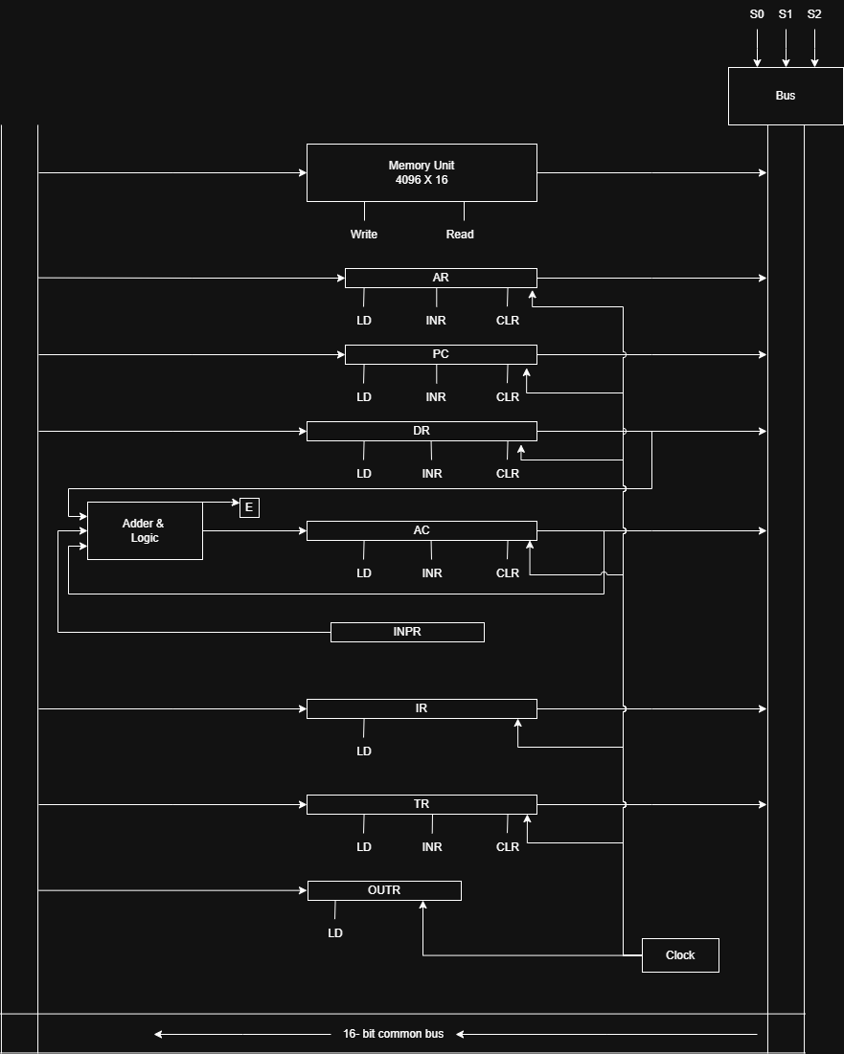

Question 2

- f(A,B,C,D) = ∑m (2,4,6,8,10,12,14)
AB\CD | 00 | 01 | 11 | 10
00 |  |  |  | 1
01 | 1 |  |  | 1
11 | 1 |  |  | 1
10 | 1 |  |  | 1

F(A,B,C,D)=CD’+BD’+AD’
= D’(A+B+C)
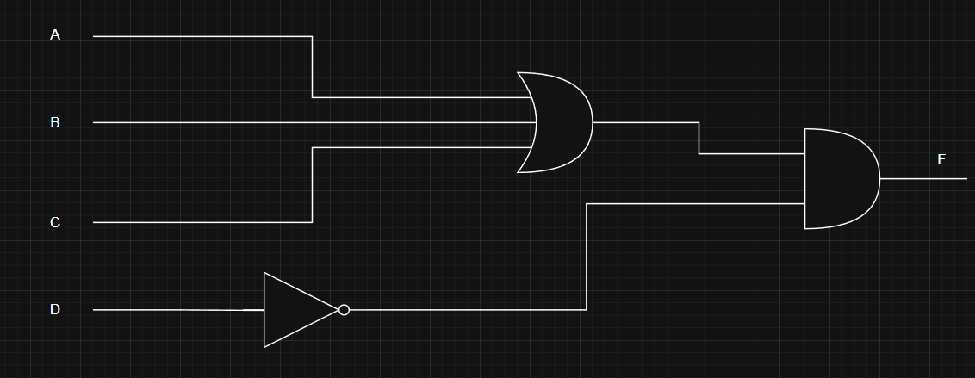
- f(A,B,C,D)=∑m(1,3,5,7,9,11,13,15)
AB\CD | 00 | 01 | 11 | 10
00 |  | 1 | 1
01 |  | 1 | 1
11 |  | 1 | 1
10 |  | 1 | 1
F(A,B,C,D) = D
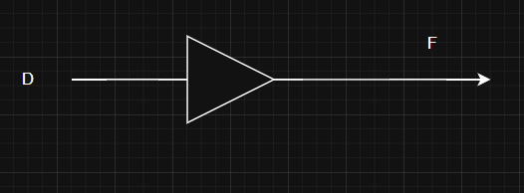

Question 3
- the word has 32 bits spited into 4 parts we know from the question that 3-bit are reserved for the addressing mode, also we have opcode represents 256 instructions which equal to 2⁸ so the opcode has 8-bit, and for the register code we have 64 registers so that is 2⁶ with that we have 6-bit for the registers, for the address part we have 32k that can be 2¹⁵ its 15-bit for address part.
so 3-bit for addressing mode, 8-bit for opcode, 6-bit for registers and 15-bit for addressing that is 32-bit in total
- 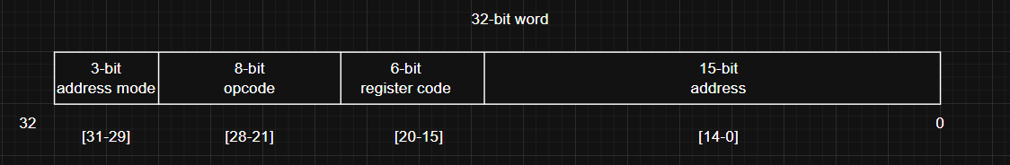

Register | Size
PC | 15-bit
AC | 32-bit
AR | 15-bit
TR | 32-bit
DR | 32-bit
IR | 32-bit

Question 4
- To determine the number of bits allocated for the operation code first we fin the other bit sizes for the other components first 128k is a 2¹⁷ here is the 17-bit for address and 1-bit for indirect addressing and we have 5-bit for register selection so now we have 17 + 1 + 5 = 23 we take that and subtract it from 32 we get 32 – 23 = 9-bit for the opcode
- 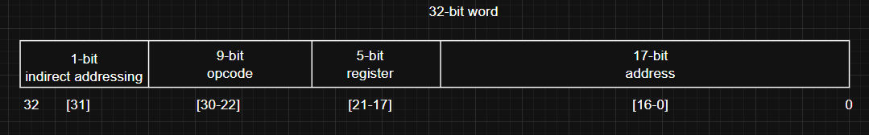
- 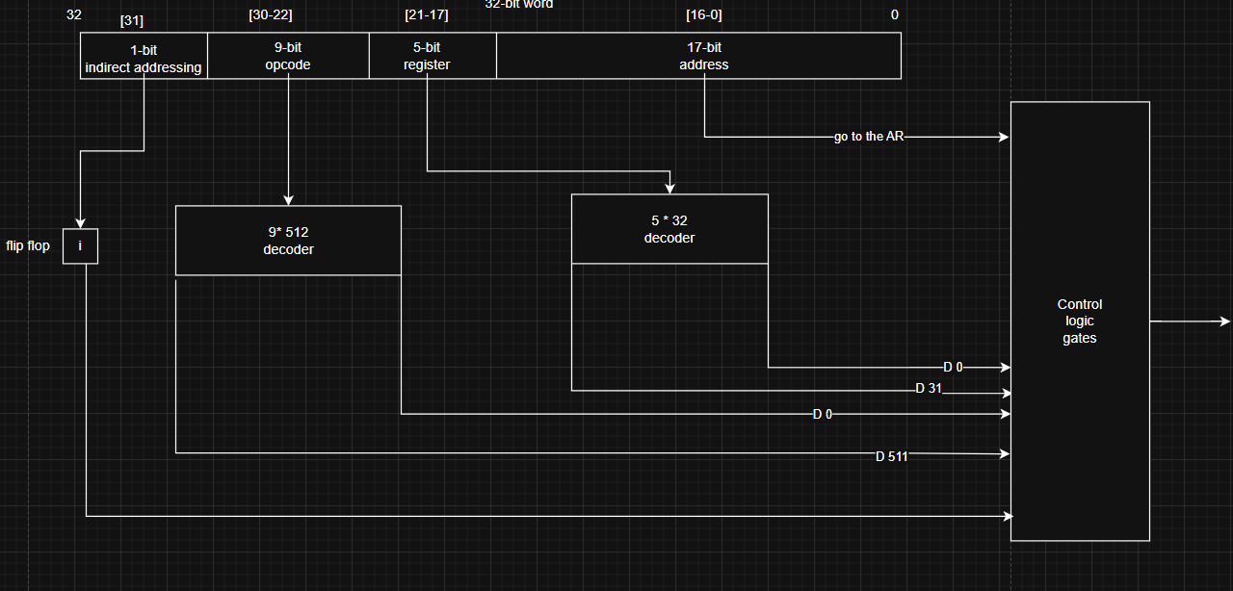

Question 5
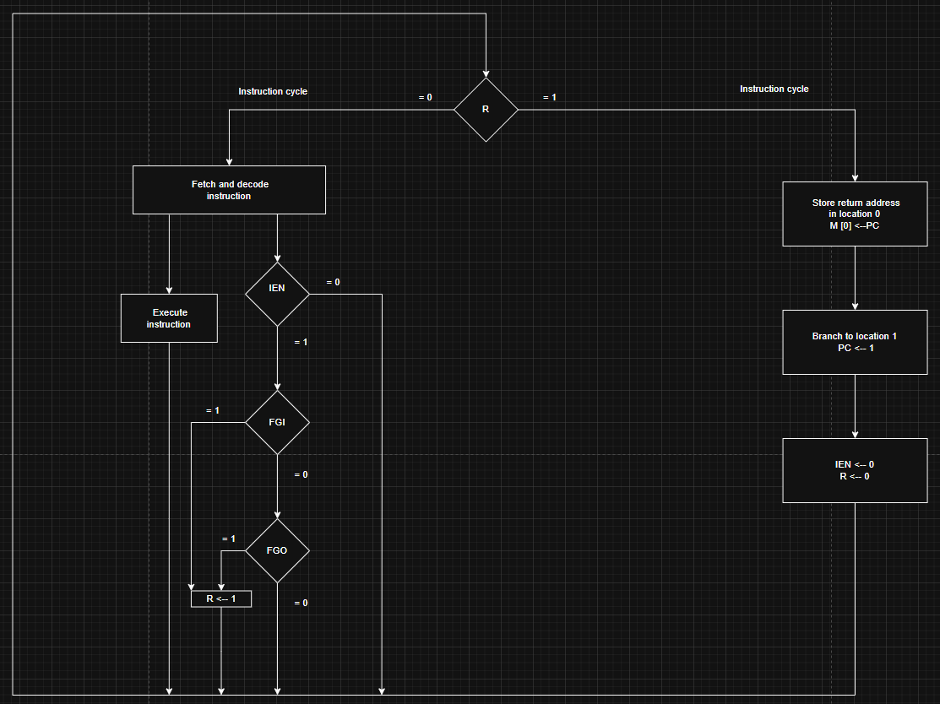
this flowchart show filp flop R and when the R = 0 the computer go into the instruction cycle on that cycle happens fetch and decode then the execution during that phase the IEN (interrupt enable flip-flop) is being checked by the control if it is 0 that means no need for the interrupt cycle so it continues to the next instruction if the IEN is 1 the control check the FGI (input flag) and FGO (output flag) if both are 0 that mean the input and output registers are not ready to transfer information and control go to the next instruction now if any of the flags turn to 1 and the IEN = 1 that means set the R to 1 and complete the execution of the current instruction and then check the value of R if its 1 go to the Interrupt cycle. The interrupt cycle is basically BSA (branch and save return address) operation the return address in the PC is stored in specific location so it can be found later this location in our BC is address 0 then the PC become 1 so PC now is at address 1 and the control clear both IEN and R (set them to 0) we do this so the program do not get interrupted while its doing the first interrupt request until the flag resets.
Note that this can only happen after T2 only and this is the statement representation
T0’T1’T2’ (IEN) (FGI + FGO) : R l

Question 6
Here is a flowchart that show the ISZ instruction
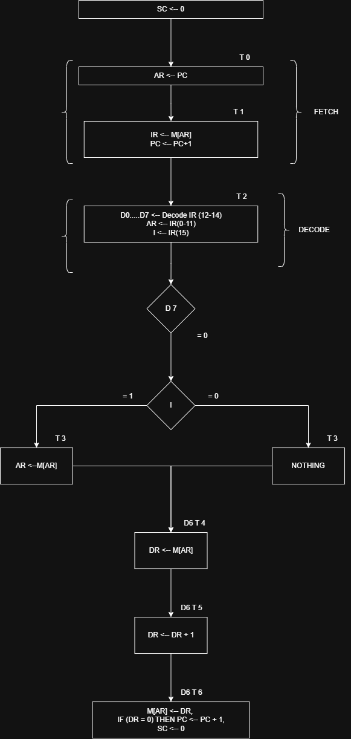

Question 7
I used a 3 by 8 mux and left the last to inputs since I am only using 6 bits
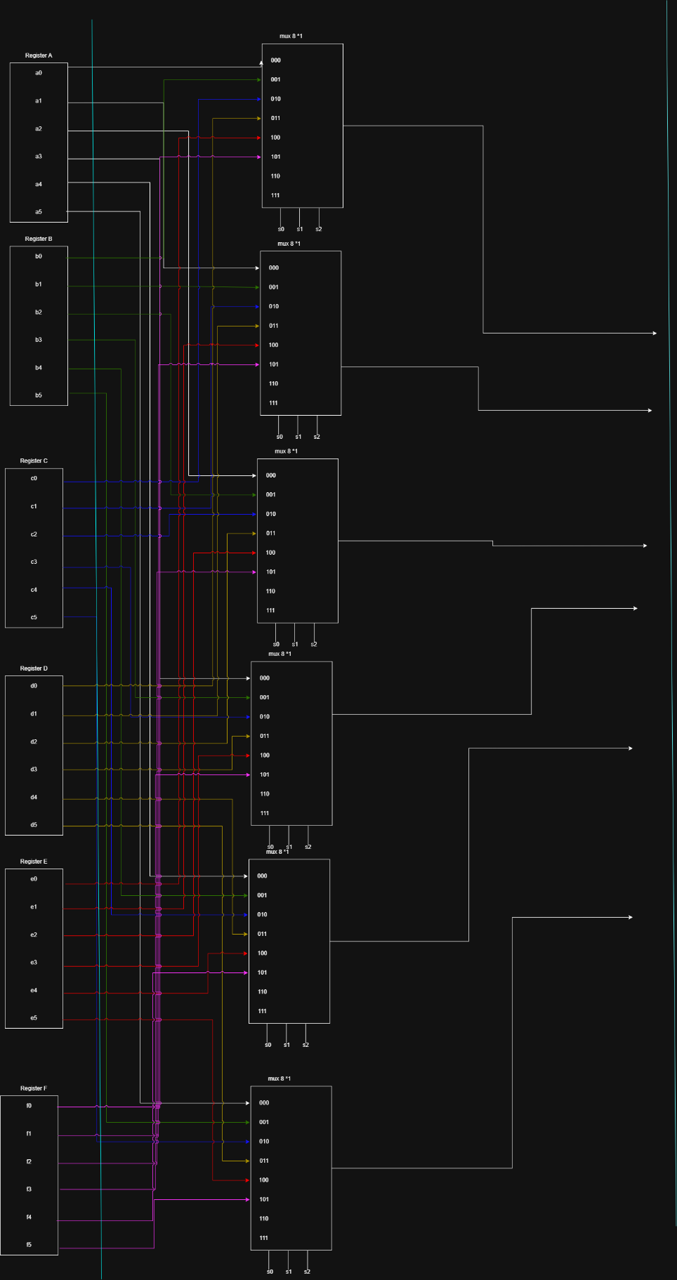

Truth table for the selectors
S0 S1 S2
0 0 0 | Reg A
0 0 1 | Reg B
0 1 0 | Reg C
0 1 1 | Reg D
1 0 0 | Reg E
1 0 1 | Reg F
1 1 0 | XXXXXXXXXXXXXXXXXXX
1 1 1 | XXXXXXXXXXXXXXXXXXX

Question 8
Convert 7A2E5FC7 to binary
Each number from hexadecimal is 4-bit in binary so
7 = 0111
A = 1010
2 = 0010
E = 1110
5 = 0101
F = 1111
C = 1100
7 = 0111
Combined
0111 1010 0010 1110 0101 1111 1100 0111
For octal we take the binary and group it as 3-bit
001 111 010 001 011 100 101 111 111 000 111
1 7 2 1 3 4 5 7 7 0 7
The octal is 17213457707

Question 9
- (+79) + (+89)
01001111
01011001 +
------------
10101000 (168 but unsigned) if we say it is signed then it will be 01011000 - 88
this is incorrect because of the overflow so there is an overflow here.
- (-79) + (-89) first we do 2’s complement
10110001
10100111 +
------------
101011000 we have a carryout here so that mean we have an overflow
- (+240) + (+26)
I can’t represent 240 in signed 8-bit so there is overflow before the addition since the range of numbers (-128 to 127)
- (-240) +(-26)
I can’t represent -240 in signed 8-bit so there is overflow before the addition since the range of numbers (-128 to 127)

Question 10
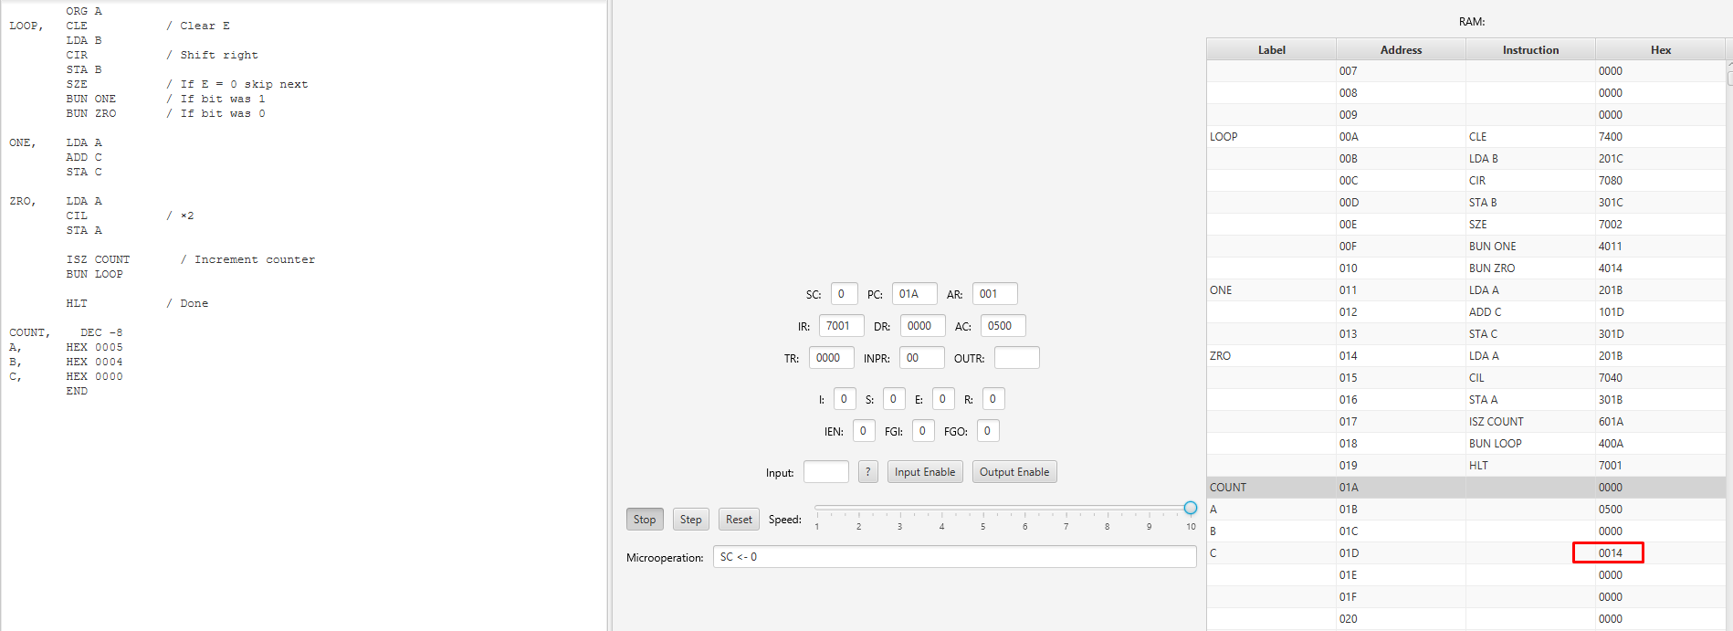
This program will multiply 5 * 4 the answer will be 20 in HEX 14

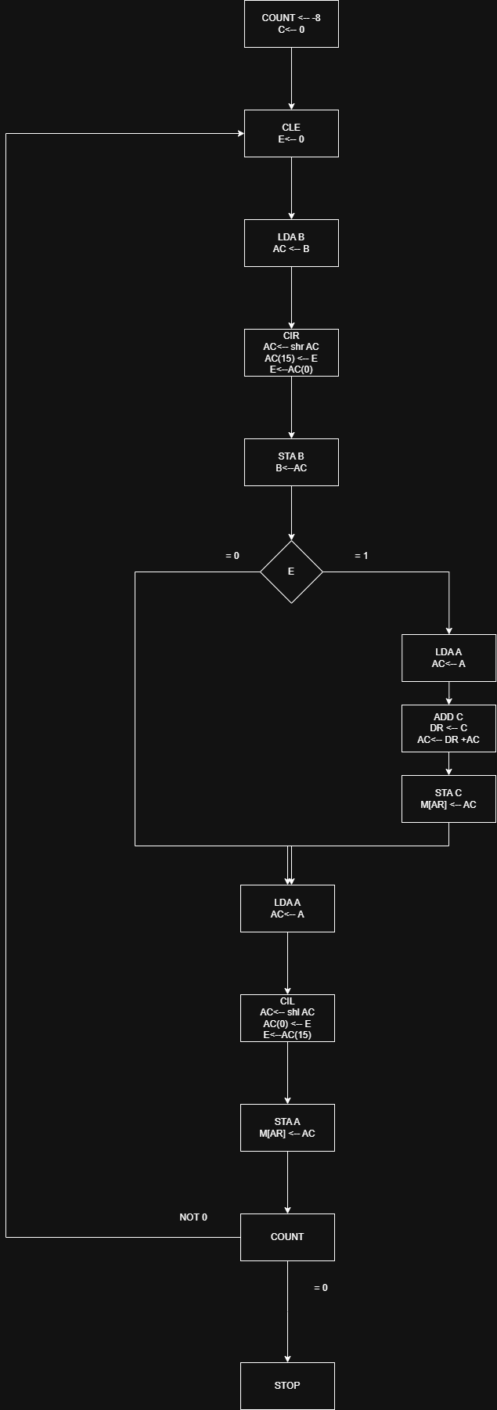
This program multiplies two 8-bit positive numbers stored in memory locations A (multiplicand) and B (multiplier). It uses the shift-and-add method, where each bit of B is checked starting from the least significant bit. If the current bit is 1, the value of A is added to a partial product stored in C. After each check, A is shifted left (multiplied by 2), and B is shifted right (divided by 2). This process repeats for 8 cycles to ensure all bits of B are checked. At the end of the loop, the final multiplication result is stored in C.
Cycle | B Before | E (Bit) | Action | A After Shift | B After Shift | C (Product)
1 | 00000100 | 0 | Skip add | 00001010 (10) | 00000010 (2) | 0
2 | 00000010 | 0 | Skip add | 00010100 (20) | 00000001 (1) | 0
3 | 00000001 | 1 | Add A to C | 00101000 (40) | 00000000 (0) | 20
4 | 00000000 | 0 | Skip add | 01010000 (80) | 00000000 (0) | 20
5 | 00000000 | 0 | Skip add | 10100000 (160) | 00000000 (0) | 20
6 | 00000000 | 0 | Skip add | 01000000 (64) | 00000000 (0) | 20
7 | 00000000 | 0 | Skip add | 10000000 (128) | 00000000 (0) | 20
8 | 00000000 | 0 | Skip add | 00000000 (0) | 00000000 (0) | 20
it run for 8 times because we are using 8 bit numbers.

Question 11
I have this expression
A/B + (C-D)/E + F/(G-H)
- The postfix for it is
AB / CD- E / + FGH-/+
- For simplicity I will give numbers
A = 10 B = 2 C = 8 D = 3 E = 5 F = 12 G = 7 H = 3
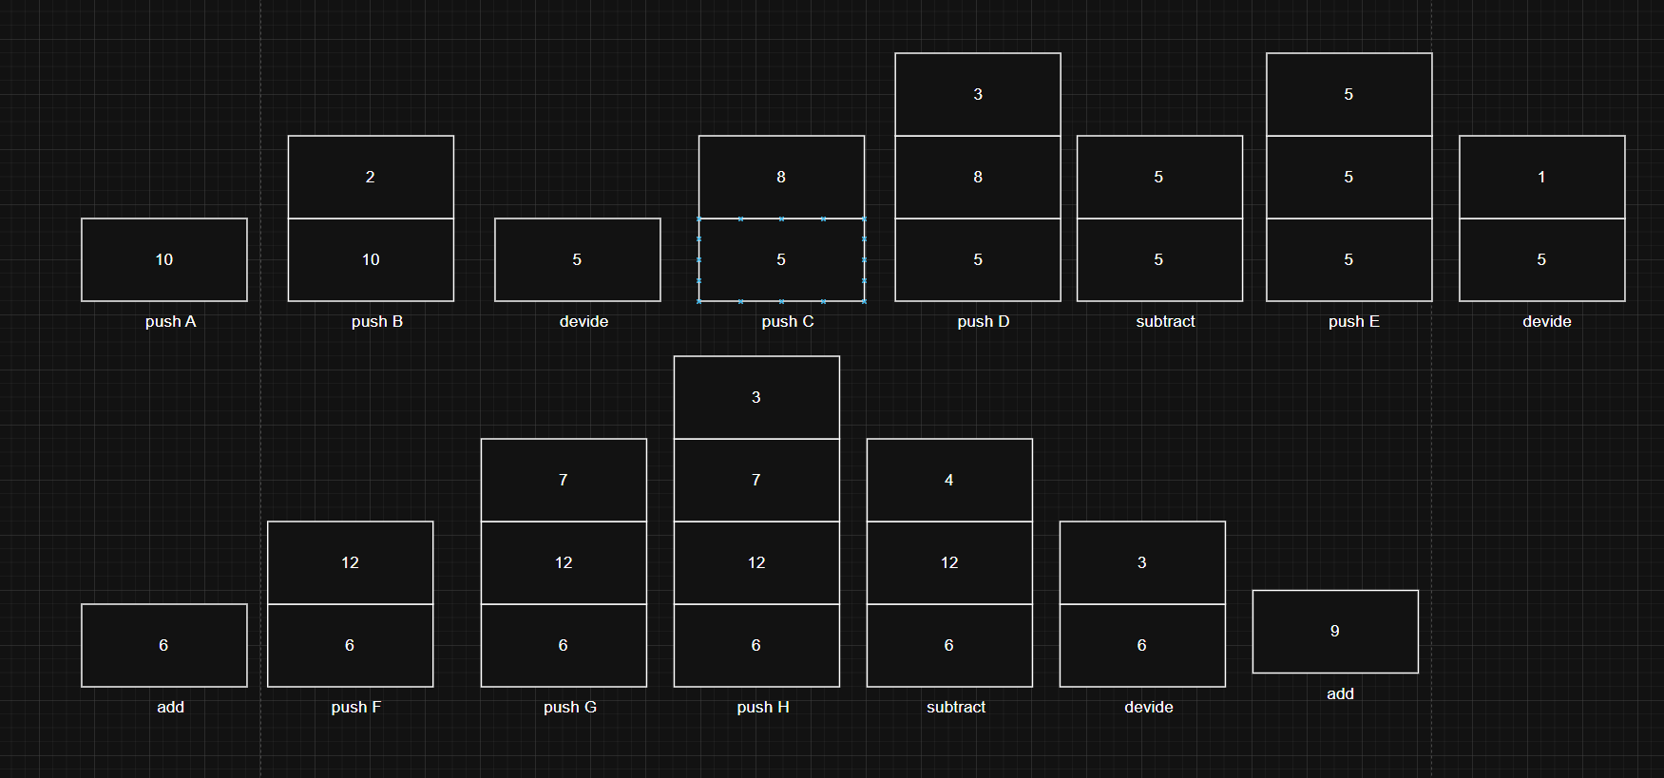

Question 12
- ABCDEFGH+-*-/+*
= A *(B+(C/(D-(E*(F-(G+H))))))
- ABCDEFGH-*+*--/
= A/(B-(C-(D*(E+(F*(G-H))))))

Question 13
- Time for non pipeline = n * t_{n} = 80 task * 100ns for each task = 80 * 100ns = 8000ns
- Time for the pipeline system T = (k + n - 1) * clock cycle
= (7 + 80 – 1) * 6 = 516ns
- Speedup ratio S = time for non pipeline / time for the pipeline system
= 8000/516 = 15.5

Question 14
Reduced Instruction Set Architecture (RISC)
the main idea of this is to simplify hardware by using an instruction set mad of basic steps for example a load command will load data and store command will store the data.
The RISC has some characteristics like the instructions are simple so it is also simple to decode it, also the instructions come I less than one word size, it only need a single clock cycle, it has more general purpose registers than the CISC also a simple addressing modes, fewer data types and we can create a pipeline system with it.
For advantages we have simpler instruction that means the processor use small amount of simple instruction that will make it easier to decode and make if fast to execute, it has low power consumption that mean it need less power to process and be great for portable devices. On the other hand it has some disadvantages if I want to preform a complex task I will need more instructions that will cause another problem which is more memory usage, and finally creating RISC processors can be expensive.
Complex Instruction Set Architecture (CISC)
The idea of this is that one instruction will do all the loading, evaluating and storing operation for example multiplication will do the 3 instruction so it is complex.
The CISC has some characteristics like it has complex instruction so it will have complex decoding the opposite of the RISC, also the instruction is larger than one word size, instruction may take longer the one clock cycle, it also has less general purpose register than thee RISC also it has complex addressing modes and more data types.
Basically the opposite of the RISC if we are talking about the characteristics.
For the advantages it has small code size since the complex instruction use multiple operations, also since the instruction are more complex it will take less space in the memory so it is memory efficient and it has large user base so that mean more available software. On the other hand the processors take longer time to execute instructions because its more complex and take longer to decode them, the complexity of the instructions make them harder to design and manufacture, and it consume more power than the RISC because of the complex instruction set.

Reference
GeeksforGeeks (2018). RISC and CISC in Computer Organization. [online] GeeksforGeeks. Available at: https://www.geeksforgeeks.org/computer-organization-architecture/computer-organization-risc-and-cisc/ [Accessed 13 Jun. 2025].
‌

